Homeowners’ Association
Newsletter Spring 2024
www.surprisevalleyhoa.com
HOA Board News
On February 20th, SVHOA held its annual elections and presentation. Thank you to all who volunteer their time and skills to help keep Surprise Valley well-managed and attractive. The annual homeowner’s presentation and a complete listing of HOA committee members can be found on our website.

The HOA is seeking resident volunteers to help with the Party Committee. Committee efforts require minimal time from volunteers. Please email the office for details.

2024 SVHOA Officers
Tom Wicher – President
Gary Wiggins – Vice President
Steve King – Treasurer
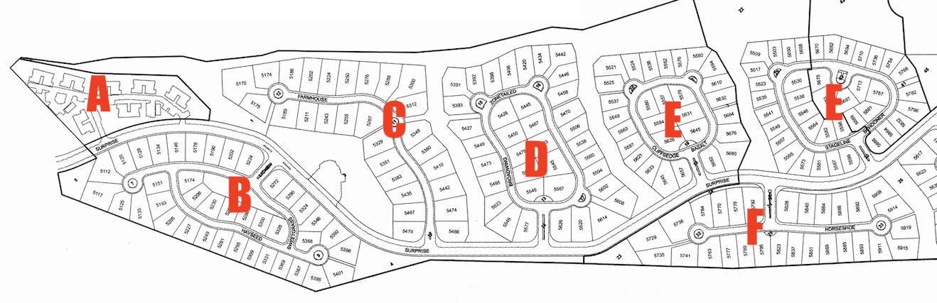
John Kirkpatrick – Secretary
2024 Neighborhood Representatives
Nate Roldan – Neighborhood A (Condos)
Joe Atalla – Neighborhood B
Gary Wiggins – Neighborhood C
Tom Wicher – Neighborhood D
Jeff Edwards – Neighborhood E
Lance Millington – Neighborhood F
Steve King – Neighborhood H
Alan Kahn – Neighborhood I
Steve Jackson – Neighborhood J
Franziska Gollar– Neighborhood K
Kathy Reavy – Neighborhood L
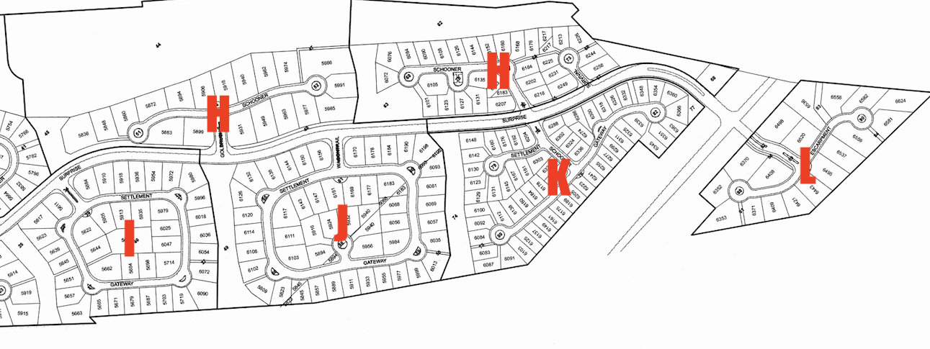
Neighborhood Manager Position
The Surprise Valley Homeowners Association is a self-managed HOA, which means SVHOA does not employ a 3rd party management company for the community. The neighborhood manager is an employee of the Association, and reports to the Board of Directors. The manager is responsible for the day-to-day business and maintenance of the association, including communication and homeowner interface.

Applications for the part-time, paid position are being accepted with interviews planned for the 1st quarter.

The neighborhood manager job description can be found on the website. Please email your question to manager@surprisevalleyhoa.com

Important Spring Dates
April 12th – Homeowner Irrigation Turn-on
May 24th – Pools Open
June 8th – Annual Yard Sale

Homeowner Irrigation
Homeowner irrigation water turn-on for the season will begin on Friday, April 12th, pending any system issues. Please do not use the irrigation system prior to this date, as Hopkins Landscaping will be testing and repairing the system which requires optimal water pressure.
Each home has a designated irrigation time to ensure adequate water pressure for all users. The irrigation schedule can be found at surprisevalleyhoa.com under “Documents/Forms”. Please adhere to your assigned time to conserve water and water pressure.
Overwatering is an ongoing issue so be courteous and double-check that your sprinklers do not overspray onto your neighbor’s property.

Pool Season
The planned pool season for both SV pools is Friday, May 24th through Monday, September 2nd.

Surprise Valley will be hiring two pool monitors for the summer pool season.
Information and qualifications are posted on our website. Submit your resume via email to: manager@surprisevalleyhoa.org or drop off to the mailbox next to the Farmhouse front door. Resumes due by April 30, 2023.

Neighborhood and Farmhouse Improvements
The cedar fencing on south side of Surprise Way and pathways is scheduled to be power washed and stained when weather permits, after some posts and bottom rails are repaired.

The Farmhouse deck is scheduled to be sanded and stained and the window trim painted.

Deppel Painting has contracted to do the work.
They are offering to all Surprise Valley Homeowners, discounted rates for all painting services. Call Brad, 208-800-1247 or deppelpainting.com for a free estimate.

SV Yard Sale
Plan ahead for the Surprise Valley Yard sale to be held Saturday, June 8^{th,} 8am till 2pm. Simply stage the item you want to sell on your driveway with a hot price, and watch it disappear.

The sale will be communicated in the Statesman, Facebook and Nextdoor apps, as well as neighborhood signage.

Newsletter Changes
Starting with the Summer 2024 quarter (July 1), this quarterly Newsletter will be emailed to homeowners, rather than being included with your monthly invoice. The Newsletter is also posted on the Surprise Valley website. You will still be receiving the quarterly HOA dues invoices via hard copy mail. This will reduce printing and mailing costs.

